JAVA PROGRAMS – WEEK WISE
WEEK – I
1. Write a Java Program that works as simple calculator .Use grid layout to arrange buttons for the digits and for the +,-,*,% operations .Add text field to display the results, Handle any possible exceptions like divide by zero.
package calc;
import javax.swing.*;
import javax.swing.event.*; import java.awt.*;
import java.awt.event.*;
class A extends JFrame implements ActionListener {
public JButton b1, b2, b3, b4, b5, b6, b7, b8, b9, b10, b11, b12, b13, b14, b15, b16;
public JTextField tf1;
public JPanel p; public String v = ""; public String v1 = "0"; public String op = "";
public A() { setDefaultCloseOperation(JFrame.EXIT_ON_CLOSE); setSize(400, 400);
p = new JPanel(new FlowLayout()); tf1 = new JTextField(10); p.add(tf1);
add(p);
setLayout(new GridLayout(0, 3));
b1 = new JButton("1"); b1.addActionListener(this); add(b1);
b2 = new JButton("2"); b2.addActionListener(this); add(b2);

b3 = new JButton("3"); b3.addActionListener(this); add(b3);
b4 = new JButton("4"); b4.addActionListener(this); add(b4);
b5 = new JButton("5"); b5.addActionListener(this); add(b5);
b6 = new JButton("6"); b6.addActionListener(this); add(b6);
b7 = new JButton("7"); b7.addActionListener(this); add(b7);
b8 = new Jbutton("8");
b8.addActionListener(this);
add(b8);
b9 = new JButton("9"); b9.addActionListener(this); add(b9);
b10 = new JButton("0"); b10.addActionListener(this); add(b10);
b11 = new JButton("+"); b11.addActionListener(this); add(b11);
b12 = new JButton("-"); b12.addActionListener(this); add(b12);
b13 = new JButton("*"); b13.addActionListener(this); add(b13);
b14 = new JButton("/"); b14.addActionListener(this); add(b14);
b16 = new JButton("%"); b16.addActionListener(this); add(b16);
b15 = new JButton("="); b15.addActionListener(this); add(b15);
setVisible(true);
}
public void actionPerformed(ActionEvent ae) { String b = ae.getActionCommand();
switch (b) { case "1": {
v = v + "1"; tf1.setText(v);
}
break; case "2": {
v = v + "2"; tf1.setText(v);
}
break; case "3": {
v = v + "3"; tf1.setText(v);
}
break; case "4": {
v = v + "4";
tf1.setText(v);
}
break; case "5": {
v = v + "5"; tf1.setText(v);
}
break; case "6": {
v = v + "6"; tf1.setText(v);
}
break; case "7": {
v = v + "7"; tf1.setText(v);
}
break; case "8": {
v = v + "8"; tf1.setText(v);
}
break; case "9": {
v = v + "9"; tf1.setText(v);
}
break; case "0": {
v = v + "0"; tf1.setText(v);
}
break; case "+": {
op = "+";
v1 = tf1.getText(); v = "";
}
break; case "-": {
op = "-";
v1 = tf1.getText(); v = "";
}
break; case "*": {
op = "*";
v1 = tf1.getText(); v = "";
}
break;
case "/": { op = "/";
v1 = tf1.getText(); v = "";
}
break; case "%": {
op = "%";
v1 = tf1.getText(); v = "";
}
break; case "=": {
switch (op) { case "+": {
v = tf1.getText(); if (v.equals("")) {
v = "0";
}
long i = Long.parseLong(v1) + Long.parseLong(v); tf1.setText(String.valueOf(i));
v="";
}
break; case "-": {
v = tf1.getText(); if (v.equals("")) {
v = "0";
}
long i = Long.parseLong(v1) - Long.parseLong(v); tf1.setText(String.valueOf(i));
v="";
}
break; case "*": {
v = tf1.getText(); if (v.equals("")) {

v = "0";
}
long i = Long.parseLong(v1) * Long.parseLong(v); tf1.setText(String.valueOf(i));
v="";
}
break; case "/": {
try {
v = tf1.getText(); if (v.equals("")) {
v = "0";
}
ong i = Long.parseLong(v1) / Long.parseLong(v); tf1.setText(String.valueOf(i));
v="";
} catch (Exception ex) { JOptionPane.showMessageDialog(this, ex.getMessage());
}
}
break; case "%": {
try {
v = tf1.getText(); if (v.equals("")) {
v = "0";
}
long i = Long.parseLong(v1) % Long.parseLong(v); tf1.setText(String.valueOf(i));
v="";
} catch (Exception ex) { JOptionPane.showMessageDialog(this, ex.getMessage());
}
}
break;
}
}
break;
}
}
}
public class Calc {
public static void main(String[] args) { A a = new A();
}
}
EXPECTED OUTPUT
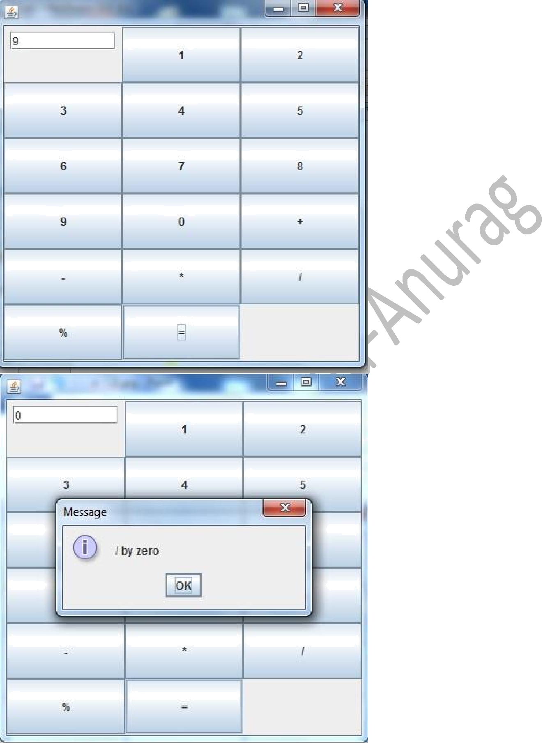

WEEK – II
2. Develop an Applet in java that displays a Simple Message

import java.applet.Applet;
import java.awt.*;
public class HelloJava extends Applet {
public void init() {
}
public void paint(Graphics g) {
g.setColor(Color.blue);
Font font = new Font("verdana", Font.BOLD, 15);
g.setFont(font);
g.drawString("Hello Java", 10, 100);
}
}

EXPECTED OUTPUT
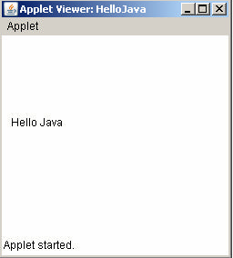

WEEK – III
3. Develop an Applet in java that receives an integer in one TextField, and computes its Factorial value and returns it in another textfield, when button named “Compute” is clicked

import java.applet.Applet;
import java.awt.*;
import java.awt.event.*;
public class Fact extends Applet implements ActionListener {
Label l1, l2, l3;
TextField tf1, tf2;
Button b1;
public void init() {
setSize(400, 200);
FlowLayout g = new FlowLayout();
setLayout(g);
l1 = new Label("Enter Value");
l1.setForeground(Color.BLUE);
add(l1);
tf1 = new TextField(5);
tf1.setText("0");
add(tf1);
b1 = new Button("Compute");
b1.addActionListener(this);
add(b1);
l3 = new Label();
add(l3);
l2 = new Label("factorial: ");
l2.setForeground(Color.BLUE);
add(l2);
tf2 = new TextField(5);
add(tf2);
}
public void actionPerformed(ActionEvent ae) {
long n = Integer.parseInt(tf1.getText());
long f = 1;
while (n != 0) {
f = f * n;
n--;
}
tf2.setText(String.valueOf(f));
}
}

EXPECTED OUTPUT

WEEK – IV
4. Write a Program that creates User Interface to perform Integer Divisions. The user enters two numbers in text fields, Num1 and Num2.The division of Num1 and Num2 is displayed in the result field when the divide button clicked. If Num1 or Num2 were not integer, the program would throw a NumberFormatException, If Num2 is Zero, and the program would throw an Arithmetic Exception. Display the Exception in message box.

package javaapplication9;
import java.awt.*;
import java.awt.event.*;
import javax.swing.*;
import javax.swing.event.*;
class A extends JFrame implements ActionListener {
JLabel l1, l2, l3;
JTextField tf1, tf2, tf3;
JButton b1;
A() {
setDefaultCloseOperation(JFrame.EXIT_ON_CLOSE);
setLayout(new FlowLayout());
l1 = new JLabel("Welcome");
setSize(800, 400);
l1 = new JLabel("Enter Number1");
add(l1);
tf1 = new JTextField(10);
add(tf1);
l2 = new JLabel("Enter Number2");
add(l2);
tf2 = new JTextField(10);
add(tf2);
l3 = new JLabel("Result");
add(l3);
tf3 = new JTextField(10);
add(tf3);
b1 = new JButton("Divide");
add(b1);
b1.addActionListener(this);
setVisible(true);
}
public void actionPerformed(ActionEvent ae) {
try {
int a = Integer.parseInt(tf1.getText());
int b = Integer.parseInt(tf2.getText());
if(b==0)
throw new ArithmeticException(" Divide by Zero Error");
float c = (float) a / b;
tf3.setText(String.valueOf(c));
} catch (NumberFormatException ex) {
JOptionPane.showMessageDialog(this, ex.getMessage());
} catch (ArithmeticException ex) {
JOptionPane.showMessageDialog(this, ex.getMessage());
}
}
}
public class JavaApplication9 {
public static void main(String[] args) {
A a = new A();
}
}

EXPECTED OUTPUT

WEEK - V

5.Write Java Program that implements a multithread application that has three threads.First thread generates random integer for every second and if the value is even,second thread computes the square of number and prints.If the value is odd,the third thread will print the value of cube of number.

package mthread;
import java.util.*;
class even implements Runnable {
public int x;
public even(int x) {
this.x = x;
}
public void run() {
System.out.println("Thread Name:Even Thread and " + x + "is even Number and Square of " + x + " is: " + x * x);
}
}
class odd implements Runnable {
public int x;
public odd(int x)
{
this.x = x;
}
public void run() {
System.out.println("Thread Name:ODD Thread and " + x + " is odd number and Cube of " + x + " is: " + x * x * x);
}
}
class A extends Thread {
public String tname;
public Random r;
public Thread t1, t2;
public A(String s) {
tname = s;
}
public void run() {
int num = 0;
r = new Random();
try {
for (int i = 0; i < 50; i++) {
num = r.nextInt(100);
System.out.println("Main Thread and Generated Number is " + num);
if (num % 2 == 0) {
t1 = new Thread(new even(num));
t1.start();
} else {
t2 = new Thread(new odd(num));
t2.start();
}
Thread.sleep(1000);
System.out.println("--------------------------------------");
}
} catch (Exception ex) {
System.out.println(ex.getMessage());}
public static void main(String[] args) {
A a = new A("One");
a.start();
}
}
EXPECTED OUTPUT

WEEK - VI

6. Write a java program for the following
i) Create a double linked list of elements
ii) Delete a given element from the above list
iii) Display the contents of the list after deletion

package week6;
import java.util.Scanner;
class Node
{
public int data;
public Node next, prev;

public Node()
{
next = null;
prev = null;
data = 0;
}
}

class DL
{
protected Node start;
protected Node end ;
public int size;

public DL()
{
start = null;
end = null;
size = 0;
}

public boolean isEmpty()
{
return start == null;
}

public int getSize()
{
return size;
}
Node create(Node hptr)
{
Node nptr,ptr;
int x=0;
System.out.println("Enter data and -1 to exit\n");

Scanner sc=new Scanner(System.in);
x=sc.nextInt();
while(x!=-1)
{

nptr=new Node();
nptr.data=x;
if(hptr==null)
{
nptr.prev=null;
nptr.next=null;
hptr=nptr;
}
else
{
ptr=hptr;
while(ptr.next!=null){
ptr=ptr.next;}
ptr.next=nptr;
nptr.prev=ptr;
nptr.next=null;
}

}
return hptr;
}

void delete(Node hptr)
{

Node dptr=hptr;
if(hptr == null)
return;
hptr=hptr.next;
hptr.prev=null;

dptr=null;
return;
}
void display(Node hptr) {
Node node = hptr;
System.out.println("1.Forward\n2.Backward");
Scanner sc=new Scanner(System.in);
int ch=sc.nextInt();
if(ch==1)
{
System.out.println("List of node in Forward order!");
while(node != null) {
System.out.println(node.data);
node = node.next;
}

}
else
{
System.out.println("List of node Backward order!");
while(node.next != null) {
node = node.next;
}
while(node != null) {
System.out.println(node.data);
node = node.prev;
}
}
}
}

public class DLL
{
public static void main(String[] args)
{
Scanner scan = new Scanner(System.in);
Node hptr=null;
DL list = new DL();
char ch;
do
{
System.out.println("\nDoubly Linked List Operations\n");
System.out.println("1. create");
System.out.println("2. delete");
System.out.println("3. display");
System.out.println("4. check empty");
System.out.println("5. get size");

int choice = scan.nextInt();
switch (choice)
{
case 1 :
hptr=list.create(hptr);
break;
case 2 :

list.delete(hptr);
break;
case 3 :

list.display(hptr);
break;

case 4 :
System.out.println("Empty status = "+ list.isEmpty());
break;
case 5 :
System.out.println("Size = "+ list.getSize() +" \n");
break;
default :
System.out.println("Wrong Entry \n ");
break;
}
/* Display List */
System.out.println("\nDo you want to continue (Type y or n) \n");
ch = scan.next().charAt(0);

} while (ch == 'Y'|| ch == 'y');
}
}

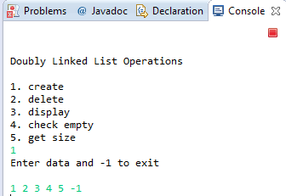
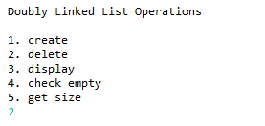
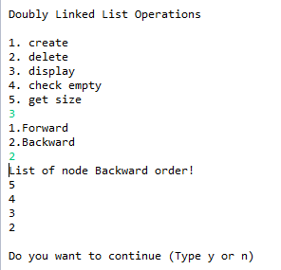

WEEK – VII

7. Write a Java Program that simulates a Traffic Light. The program lets the use select one of three lights : red, yellow or Green with radio buttons. On selecting radio button, an appropriate message with “stop” or “Ready” or “GO” should appear above the button in selected color.Intially ,there is no message shown.

import javax.swing.*;
import javax.swing.event.*;
import java.awt.*;
import java.awt.event.*;
class A extends JFrame implements ItemListener {
public JLabel l1, l2;
public JRadioButton r1, r2, r3;
public ButtonGroup bg;
public JPanel p, p1;
public A() {
setDefaultCloseOperation(JFrame.EXIT_ON_CLOSE);
setLayout(new GridLayout(2, 1));
setSize(800, 400);
p = new JPanel(new FlowLayout());
p1 = new JPanel(new FlowLayout());
l1 = new JLabel();
Font f = new Font("Verdana", Font.BOLD, 60);
l1.setFont(f);
add(l1);
p.add(l1);
add(p);
l2 = new JLabel("Select Lights");
p1.add(l2);
JRadioButton r1 = new JRadioButton("Red Light");
r1.setBackground(Color.red);
p1.add(r1);
r1.addItemListener(this);
JRadioButton r2 = new JRadioButton("Yellow Light");
r2.setBackground(Color.YELLOW);
p1.add(r2);
r2.addItemListener(this);
JRadioButton r3 = new JRadioButton("Green Light");
r3.setBackground(Color.GREEN);
p1.add(r3);
r3.addItemListener(this);
add(p1);
bg = new ButtonGroup();
bg.add(r1);
bg.add(r2);
bg.add(r3);
setVisible(true);
}
public void itemStateChanged(ItemEvent i) {JRadioButton jb = (JRadioButton) i.getSource();
switch (jb.getText()) {
case "Red Light": {
l1.setText("STOP");
l1.setForeground(Color.red);
}
break;
case "Yellow Light": {
l1.setText("Ready");
l1.setForeground(Color.YELLOW);
}
break;
case "Green Light": {
l1.setText("GO");
l1.setForeground(Color.GREEN);
}
break;
}
}
}
public class TLights {
public static void main(String[] args) {
A a = new A();
}
}
EXPECTED OUTPUT

WEEK-VIII
8. Write a Java program to create an abstract class named Shape that contains two integers and an empty method named print Area (). Provide three classes named Rectangle, Triangle, and Circle such that each one of the classes extends the class Shape. Each one of the classes contains only the method print Area () that prints the area of the given shape.

import java.util.Scanner;
abstract class Shape
{
int a,b;
abstract void printArea();
}
class Rectangle extends Shape
{
void printArea()
{
System.out.println("Area of Rectangle="+ a*b);
}
}
class Triangle extends Shape
{
void printArea()
{
double area=0.5*a*b;
System.out.println("Area of Triangle="+ area);
}
}
class Circle extends Shape
{
void printArea()
{
double area=3.14*a*a;
System.out.println("Area of Circle="+area);
}
}
class AbstractClass
{
public static void main(String args[])
{
Scanner sc=new Scanner(System.in);
Rectangle r=new Rectangle();
Triangle t=new Triangle();
Circle c=new Circle();
System.out.println("Enter length and breadth of rectangle:");
r.a=sc.nextInt();
r.b=sc.nextInt();
System.out.println("Enter height and base of triangle:");
t.a=sc.nextInt();
t.b=sc.nextInt();
System.out.println("Enter radius circle:");
c.a=sc.nextInt();
r.printArea();
t.printArea();
c.printArea();

}
}

Expected Output:
Enter length and breadth of rectangle:
8
4
Enter height and base of triangle:
5
3
Enter radius circle:
4
Area of Rectangle=32
Area of Triangle=7.5
Area of Circle=50.24
WEEK – IX
9. Suppose that a table named Table.txt is stored in a text file. The First line in the file is the header, and the remaining lines correspond rows in table. The elements are separated by commas. Write java program to display the table using Label in Grid Layout.

package tbl;
import java.io.*;
import java.util.*;
import java.awt.*;
import java.awt.event.*;
import javax.swing.*;
import javax.swing.event.*;
class A extends JFrame {
public A() {
setSize(400, 400);
setDefaultCloseOperation(JFrame.EXIT_ON_CLOSE);
GridLayout g = new GridLayout(0, 3);
setLayout(g);
try {
FileInputStream fin = new FileInputStream("D:\\emp.txt");
Scanner sc = new Scanner(fin).useDelimiter(",");
String[] arrayList;
String a;
while (sc.hasNextLine()) {
a = sc.nextLine();
arrayList = a.split(",");
for (String i : arrayList) {
add(new JLabel(i));
}
}
} catch (Exception ex) {
}
setDefaultLookAndFeelDecorated(true);
pack();
setVisible(true);
}
}
public class Tbl {
public static void main(String[] args) {
A a = new A();
}
}

EXPECTED OUTPUT

WEEK - X
10.Write a Java Program that handles all mouse events and show event name at the center of the window when the mouse event is fired.(Use Adapter Classes)
package mevents;
import javax.swing.*;
import java.awt.*;
import javax.swing.event.*;
import java.awt.event.*;
class A extends JFrame implements MouseListener {
JLabel l1;
public A() {
setDefaultCloseOperation(JFrame.EXIT_ON_CLOSE);
setSize(400, 400);
setLayout(new GridBagLayout());
l1 = new JLabel();
Font f = new Font("Verdana", Font.BOLD, 20);
l1.setFont(f);
l1.setForeground(Color.BLUE);
l1.setAlignmentX(Component.CENTER_ALIGNMENT);
l1.setAlignmentY(Component.CENTER_ALIGNMENT);
add(l1);
addMouseListener(this);
setVisible(true);
}
public void mouseExited(MouseEvent m) {
l1.setText("Mouse Exited");
}
public void mouseEntered(MouseEvent m) {
l1.setText("Mouse Entered");
}
public void mouseReleased(MouseEvent m) {
l1.setText("Mouse Released");
}
public void mousePressed(MouseEvent m) {
l1.setText("Mouse Pressed");
}
public void mouseClicked(MouseEvent m) {
l1.setText("Mouse Clicked");
}
}
public class Mevents {
public static void main(String[] args) {
A a = new A();
}
}

EXPECTED OUTPUT

WEEK - XI

11. Write a java program that loads names and phone numbers from the text file where data is organized as one line per record and each field in record are separated by a tab(\t).It takes a name or phone number as input and prints corresponding other value from hash table(hint: use Hash Table)

import java.util.*;
import java.io.*;
public class Hashtbl {
public static void main(String[] args) {
try {
FileInputStream fs = new FileInputStream("D:\\ph.txt");
Scanner sc = new Scanner(fs).useDelimiter("\\s+");
Hashtable<String, String> ht = new Hashtable<String, String>();
String[] arrayList;
String a;
System.out.println("Welcome TO Eng College");
System.out.println("HASH TABLE IS");
System.out.println("--------------------------");
System.out.println("KEY : VALUE");
while (sc.hasNext()) {
a = sc.nextLine();
arrayList = a.split("\\s+");
ht.put(arrayList[0], arrayList[1]);
System.out.println(arrayList[0] + ":" + arrayList[1]);
}
System.out.println("Welcome ");
System.out.println("----MENU------");
System.out.println("----1.Search by Name------");
System.out.println("----2.Search by Mobile------");
System.out.println("----3.Exit------");
String opt = "";
String name, mobile;
Scanner s = new Scanner(System.in);
while (opt != "3") {
System.out.println("Enter Your Option 1,2,3");
opt = s.next();
switch (opt) {
case "1": {
System.out.println("Enter Name");
name = s.next();
if (ht.containsKey(name)) {
System.out.println("Mobile is " + ht.get(name));
} else {
System.out.println("Not Found");
}
}
break;
case "2": {
System.out.println("Enter mobile");
mobile = s.next();
if (ht.containsValue(mobile)) {
for (Map.Entry e : ht.entrySet()) {
if (mobile.equals(e.getValue())) {
System.out.println("Name is " + e.getKey());
}
}
} else {
System.out.println("Not Found");
}
}
break;
case "3": {
opt = "3";
System.out.println("Menu Successfully Exited");
}
break;
default:
System.out.println("Choose Option betwen 1 and Three");
break;
}
}
} catch (Exception ex) {
System.out.println(ex.getMessage());
}
}
}
EXPECTED OUTPUT
Ph.txt

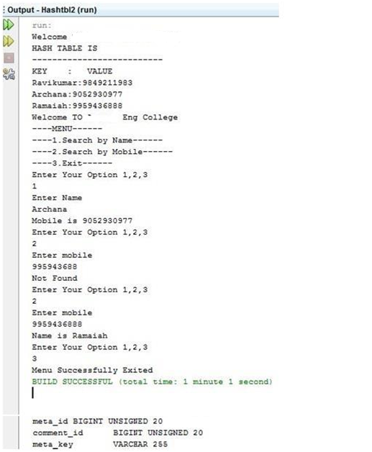

WEEK - XII

12 Write a Java program that correctly implements producer consumer problem using the concept of inter thread communication.
package week12;

class ProducerConsumer
{
int data;
boolean flag;
public synchronized void get() {
if(flag==false) {
try {
this.wait();
}
catch(InterruptedException e) {
e.printStackTrace();
}
}
System.out.println("Get "+data);
flag=false;
notify();
}
public synchronized void put(int data) {
if(flag==true) {
try {
this.wait();
}
catch(InterruptedException e){
e.printStackTrace();
}
}
this.data=data;
System.out.println("Put "+data);
flag=true;
notify();
}
}

class Producer extends Thread
{
ProducerConsumer pc;
public Producer(ProducerConsumer pc) {
this.pc=pc;
start();
}
public void run() {
for(int i=1;i<=10;i++) {
pc.put(i);
try {
sleep(1000);
}
catch(InterruptedException e){
e.printStackTrace();
}
}
}
}

class Consumer extends Thread
{
ProducerConsumer pc;
public Consumer(ProducerConsumer pc){
this.pc=pc;
start();
}

public void run() {
for(int i=1;i<=10;i++) {
pc.get();
try {
sleep(1000);
}
catch(InterruptedException e){
e.printStackTrace();

}
}
}
}
public class TestProducerConsumer {
public static void main(String[] args) {
ProducerConsumer pc=new ProducerConsumer();
Producer p=new Producer(pc);
Consumer c=new Consumer(pc);
}
}

EXPECTED OUTPUT
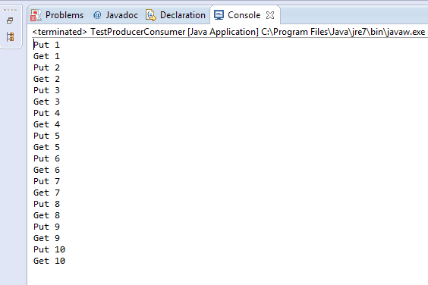

WEEK - XIII
13. Write a java program to list all the files in the directory including the files present in all its subdirectories.

import java.io.*;
public class DirectoryList {
public static void main(String[] args)throws IOException {
String directoryName;
File directory;
System.out.println("Enter a directory name: ");
BufferedReader br=new BufferedReader(new InputStreamReader(System.in));
directoryName=br.readLine();
directory = new File(directoryName);

if (directory.isDirectory() == false) {
// Program needs a directory name. Print an error message.
if (directory.exists() == false)
System.out.println("There is no such directory!");
else
System.out.println("That file is not a directory.");
}
else {
// List the contents of directory, with no indentation
// at the top level.
listContents( directory, "" );
}
} // end main()

static void listContents(File dir, String indent) {
String[] files; // List of names of files in the directory.
System.out.println(indent + "Directory \"" + dir.getName() + "\":");
indent += " "; // Increase the indentation for listing the contents.
files = dir.list();
for (int i = 0; i < files.length; i++) {
// If the file is a directory, list its contents
// recursively. Otherwise, just print its name.
File f = new File(dir, files[i]);
if (f.isDirectory())
listContents(f, indent);
else
System.out.println(indent + files[i]);
}
} // end listContents()

}
Expected Output:

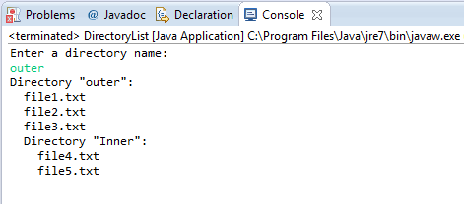

Week XIV
14. Write a Java program that implements Quick sort algorithm for sorting a list of names in ascending order.
import java.util.*;
class Quicksort
{
public void sort(String[] list)
{
qsort(list, 0, list.length-1);
System.out.println("\nAfter quick sort the list is");
for(String k:list)
{
System.out.println(k);
}
}
private void qsort(String[] list, int p, int r)
{
if (p < r)
{
int q = partition(list,p,r);
if (q == r)
{
q--;
}
qsort(list,p,q);
qsort(list,q+1,r);
}
}
private int partition (String[] list, int p, int r)
{
String pivot = list[p];
int low = p;
int high = r;
while (true)
{
while (list[high].compareTo(pivot) >= 0 && low < high)
{
high--;
}
while (list[low].compareTo(pivot) < 0 &&low < high)
{
low++;
}
if (low < high)
{
String T = list[low];
list[low] = list[high];
list[high] = T;
}
else return high;
}
}
public static void main(String args[])
{
String [] str;
int count,i;
Scanner sc=new Scanner(System.in);
System.out.print("Enter the number of strings to be inserted:");
count=sc.nextInt();
str=new String[count];
System.out.println("Enter strings:");

for(i=0;i<count;i++)
{
str[i]=sc.next();
}
Quicksort s=new Quicksort();
s.sort(str);
}
}

Expected Output:
Enter the number of strings to be inserted:6
Enter strings:
nikitha
mounica
lalitha
bindu
laxmi
harshini

After quick sort the list is
bindu
harshini
lalitha
laxmi
mounica
nikitha

WEEK XV
15. Write a Java program that implements Bubble sort algorithm for sorting in descending order and also shows the number of interchanges occurred for the given set of integers.

import java.util.Scanner;
public class Bubble_Sorting
{
public static void main(String[] args)
{
int n, temp,ichange=0;
Scanner s = new Scanner(System.in);
System.out.print("Enter no. of elements you want in array:");
n = s.nextInt();
int a[] = new int[n];
System.out.println("Enter the elements:");
for (int i = 0; i < n; i++)
{
a[i] = s.nextInt();
}
for (int i = 0; i < n; i++)
{
for (int j = i + 1; j < n; j++)
{
if (a[i] < a[j])
{
temp = a[i];
a[i] = a[j];
a[j] = temp;
ichange++;
}
}
}
System.out.println("\nDescending Order:");
for (int i = 0; i <=n - 1; i++)
{
System.out.print(a[i]+" ");
}
System.out.print("\nInterchanges occurred="+ichange);
}
}

Expected Output:
Enter no. of elements you want in array:8
Enter the elements:
78 98 45 65 12 32 49 67

Descending Order:
98 78 67 65 49 45 32 12
Interchanges occurred=11

